**Spring 2025 Asian Film Series**

**Special Theme: Film and Architecture**

Screenings at Hamilton 8: 7-10 pm

Parasite (2/21) Raise the Red Lantern (3/7) In the Mood for Love (4/4) Rouge (4/25)

Questions: Contact John Park at [jopark@ncf.edu](mailto:jopark@ncf.edu)

**Parasite (2019)**

**Bong Joon Ho**

Bong Joon Ho’s 2019 film *Parasite* represented the heightened social stratification in present-day South Korea in the form of a cinematic narrative. Its global popularity revealed that the social tension it put on screen was an allegory of multiple economic and social situations across the world. The film narrates the witty and deceptive operations of the struggling Kim family deploys to survive as parasites to the abundant resources of the blissfully naïve Park family. While the film’s narrative is structured by the sharp contrast between the two families, the film endows the distinction with a figurative appearance in its use of architecture. The poverty of Kim’s family is represented by their half-basement residence; the Parks live in a modernist building by a renowned architect, its previous owner. In foregrounding buildings, the interaction between the two families the movie narrates is dictated *entirely* by the film’s architectural configurations. Inasmuch as buildings are represented *in* the film, the same architectural elements function to shape the contours of social interactions the movie narrates. Essentially, the film is constituted by the two distinct dimensions of narrative and architecture.

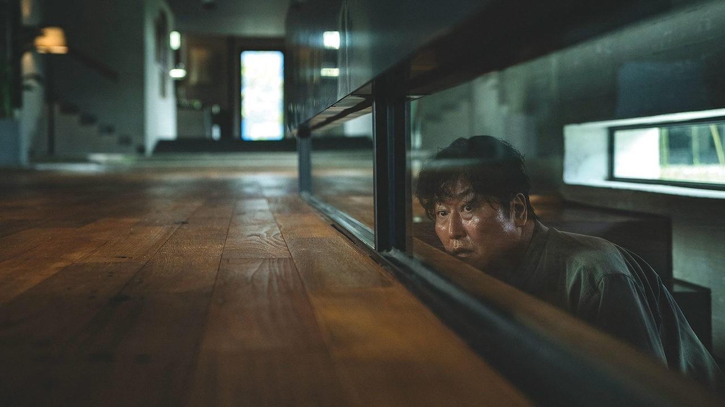

**Raise the Red Lantern (1991)**

**Zhang Yimou**

Temporarily banned in China upon its release for its critique of Confucian patriarchy, Zhang Yimou’s 1991 film *Raise the Red Lantern* centers on its heroine, Songlian, a young woman who is sold into the Chen family as the fourth wife by her stepmother after her father passes away. The film quickly brings the viewer into the internal dynamics of the Chen household, in which the four wives contend for the attention of the family patriarch. Daily, the patriarch chooses the wife to stay with for the night. And for her, red lanterns are raised outside of her residence. The viewer will quickly notice that the patriarchal structure of the family is symbolized by the imposing architecture of the Chen estate. At the same time, the viewer comes to notice that the architectural elements overwhelm the viewer on the screen, observing that the geometrical shapes of the building define the symmetrical framing of the camera characteristic of the film’s style. Formally speaking, the building exceeds the screen, so to speak, in that it determines how the cinematic shots are configured, overturning the conventional expectation that it is the camera that determines the meaning of the building. In this way, the architecture in the film comes to bear a meaning beyond the immediate symbolism the film ascribes.

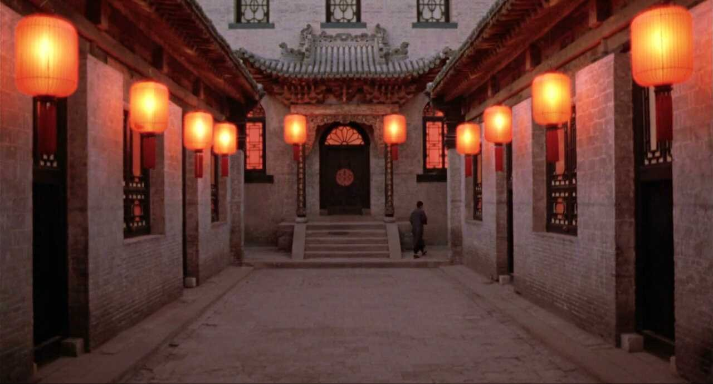

**In the Mood for Love (2000)**

**Wang Kar-wai**

In 1960s Hong Kong, Mr. Chow and Mrs. Chan are neighbors in a congested apartment who slowly learn about the affair between their spouses. Just as slowly as they find out about the affair, Chow and Chan attempt to understand the origin of the affair by playing the roles of their spouses. Unable to conclude their reenactment to its climax, they are left repeatedly restaging the affair without any sense of completion. Likewise, the feelings they develop in the process remain unspoken. The relationship’s afterlife is only a series of missed encounters. The film establishes a rhythm of its own as it plays between the invisible—the affair of their spouses taking place outside of the camera, the feelings Chow and Chan develop for each other, and their interaction kept out of the sight of their neighbors—with its use of architecture that both reveals and hides. Without a resolution that structures the narrative, their intimacy is provided a structure by the architecture of the film.

**Rouge (1987)**

**Stanley Kwan**

Stanley Kwan’s *Rouge* was shot 3 years after the 1984 Sino-British Declaration Treaty and the sense of uncertainty about its handover to China looms hauntingly in the film. The ghost of Fleur, a courtesan from Hong Kong of the 1930s, puts out a newspaper ad in modern-day 1987 Hong Kong in search of her lover, with whom she shared a suicide pact after their relationship was rejected by her lover’s family. A couple that works for the newspaper helps Fleur in her search and in the process, gains a glimpse into their tragic past. With its graceful movement between the past and modern-day Hong Kong, the historical difference is marked by the vibrant and flowery colors of buildings from Hong Kong’s precarious past standing in contrast against the colorless cityscape of modern-day Hong Kong. The past, whose ways of understanding and living were essentially tragic in mode, is qualitatively different from the modern, in which the tragic is now a thing of the past. The absence of the historical past is made visible by the film’s use of architecture, ultimately enlarging the possibilities of cinema, a medium that is dependent on showing objects and buildings that are present.

